### UK Payment Practice Analysis

### ****Introduction****

According to research by payment processing, the UK’s small and medium-sized businesses are reportedly owed £26 billion in past-due payments. In order to stop these morally repugnant practices, the UK government has decided to make all the information public so that buyers (large businesses) will be held responsible going forward.

### ****Methodology****

I performed this analysis with **SQL** using **MSSQL** under **Azure Data Studio** using an **Excel** filedownloaded from the UK government open source database [here](https://lnkd.in/dJzasS8k). The dashboard was made using **Tableau** and **Figma**.

### ****Problem Statement****

Late payments are still a difficult problem for SMEs. Large corporations frequently and consistently fail to pay their suppliers on time, which causes enormous financial losses for suppliers, particularly SME suppliers globally. According to data by payment processing processor Bacs, the UK’s small and medium-sized businesses are currently owed £26 billion in past-due payments. Invoice payments were received late 71% of the time on average for the 307 large enterprises that submitted payment reports to the UK government.

### ****Analysis Purpose****

I’ll be doing a descriptive study of the data from 2017 to the present (2022) and calculating a score or point for the buyer's credibility. You can rely on the buyer at a high point to make payments on schedule.

### ****How to read the data****

· The reporting period (start date and end date or the duration for which the buyer company has to report the payment numbers)

· Filing information (When did the company file the records)

· Whether Payments were made during the reporting period

· Payment Metrics like Average time to pay

· Distribution of Invoices spanned across different Payment duration buckets

· Standard Payment Period (Shortest and Longest)

· Typical Payment Contractual terms agreed with Suppliers

· Changes made in Payment terms and have suppliers been notified of changes etc.

### ****Data Limitations****

1. Null values were present; some of them could be altered, but the majority couldn’t, and filtering them would have changed the results of the entire analysis.

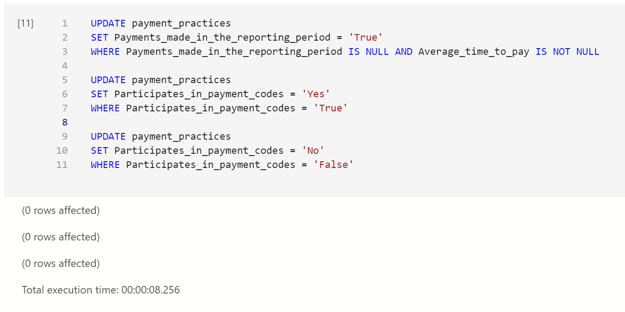

2. Some of the information is not sufficiently supported to provide a thorough prediction bias. It was an overview of all the business deals that each company had made during the reporting period.

3. Because the report was only a summary, it was challenging to provide an “average time to pay back" as a standard point because this payback duration is solely dependent on the buyer and supplier, and this information wasn’t included in the report. For instance, paying back 25 days at company A can take 200 days at company B, and both parties are content.

### ****Exploratory Data Analysis****

* UK firms recorded a total of 9359 companies and 61,972 reports between 2017 and 2022.

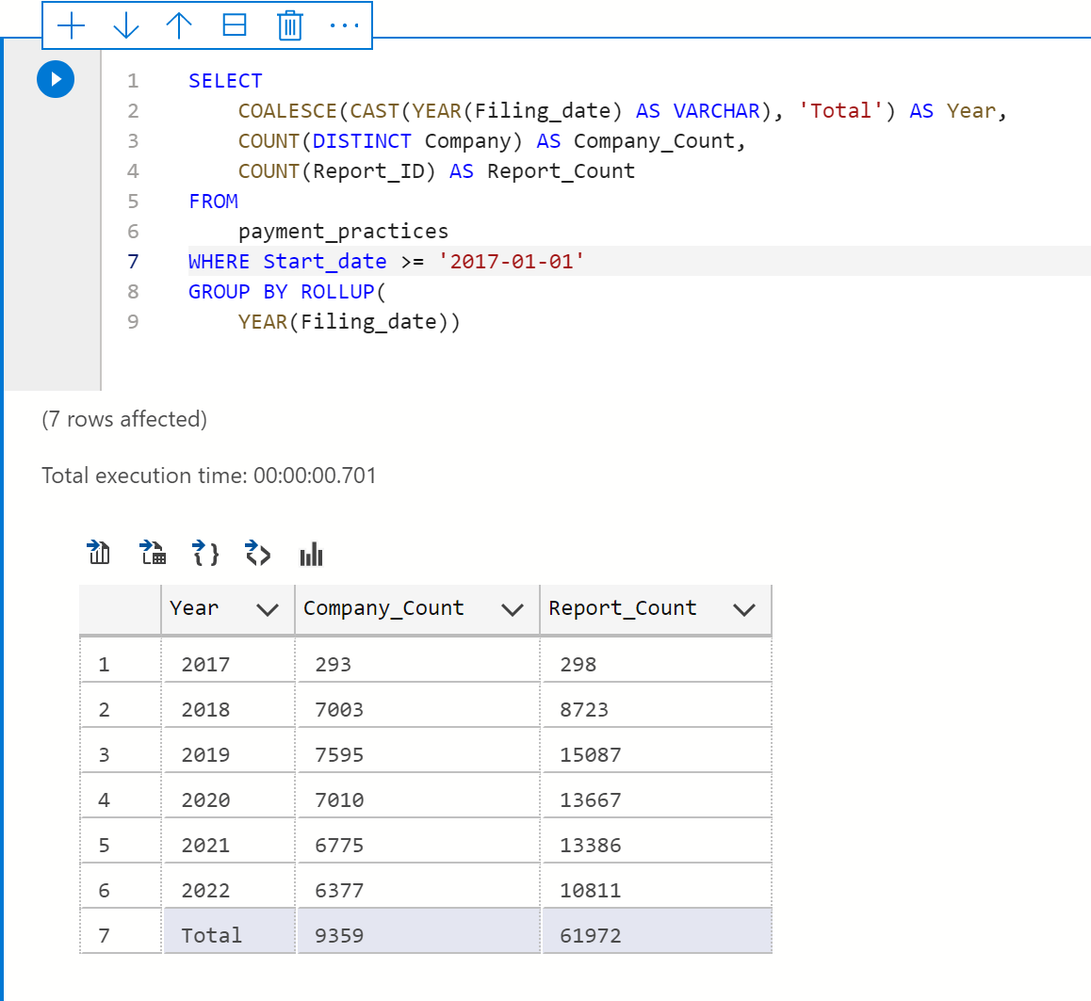

* During the reporting period, over 56,000 reports which is **90%** of all reports had payments paid.

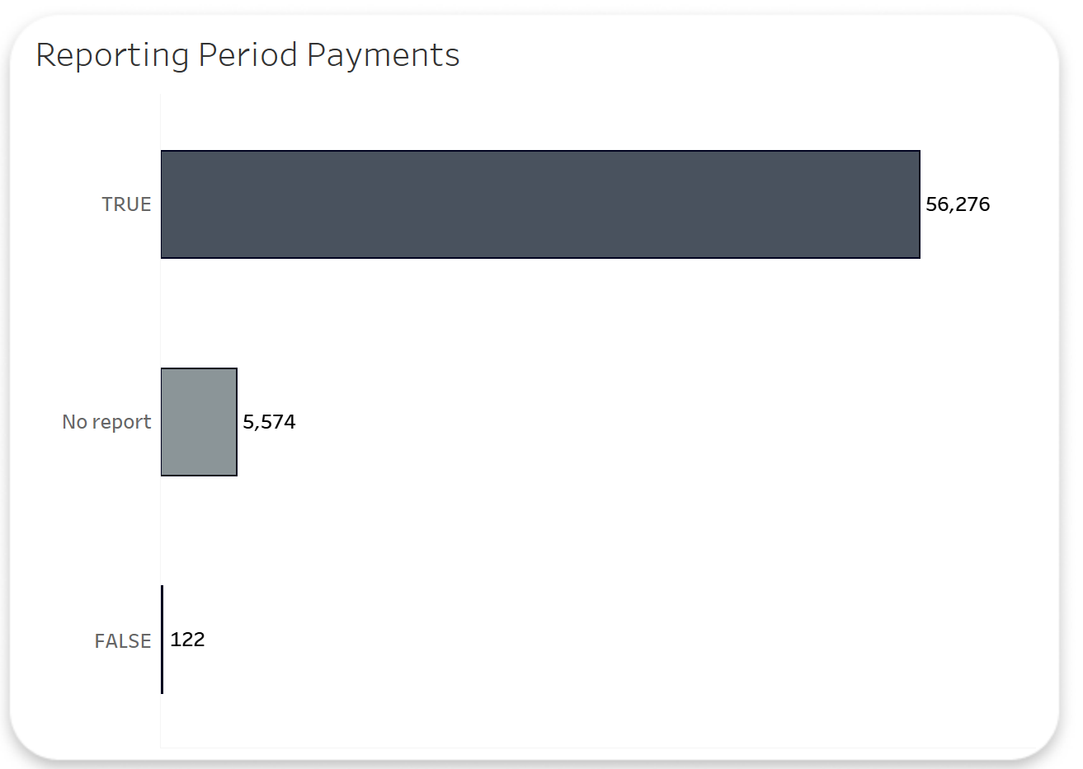

“True” means businesses engaged in a qualifying contract and making payment during the reporting period.

“No report” means a business did not enter into any qualifying contract and, therefore, no payments were made.

“False” means businesses that signed up for eligible contracts during the reporting period but made no payments.

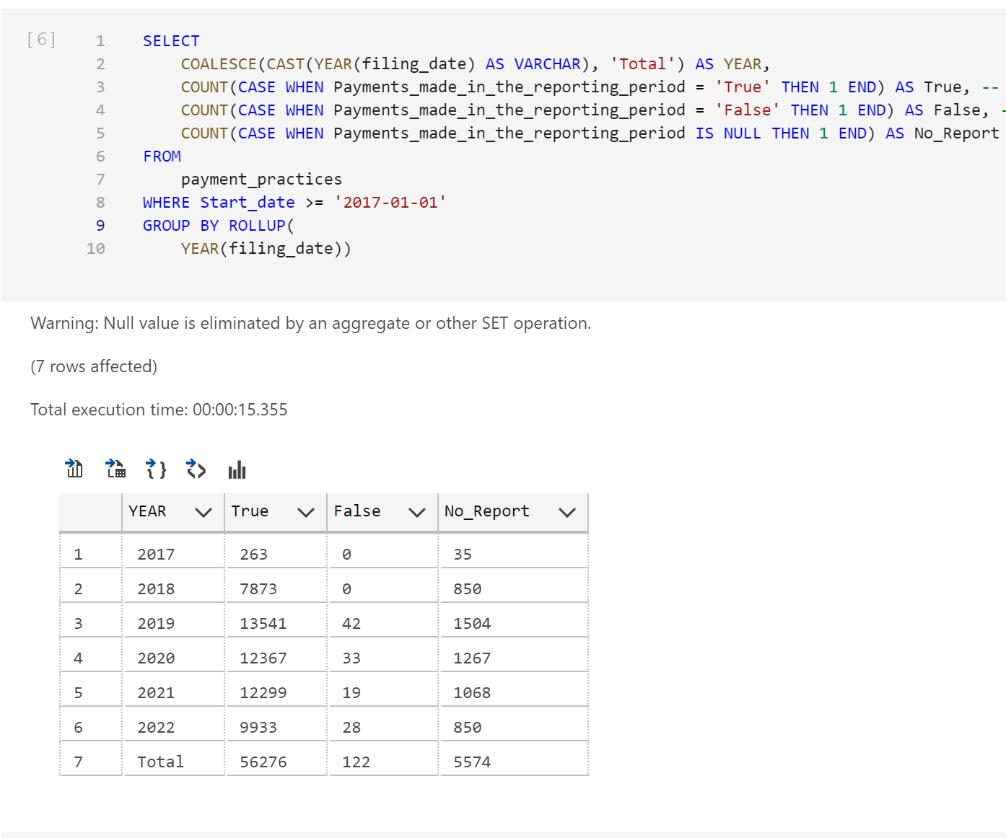

* To address late payments, payment codes were revised in early 2019 after being introduced in 2008. A business with a payment code is thought to be one that pays promptly because the penalty for late payment is having the code removed with a bad public notice. Over the years, there has been a decline in the use of payment codes, most likely as a result of the numerous firms that have had their codes revoked for bad payment practices.

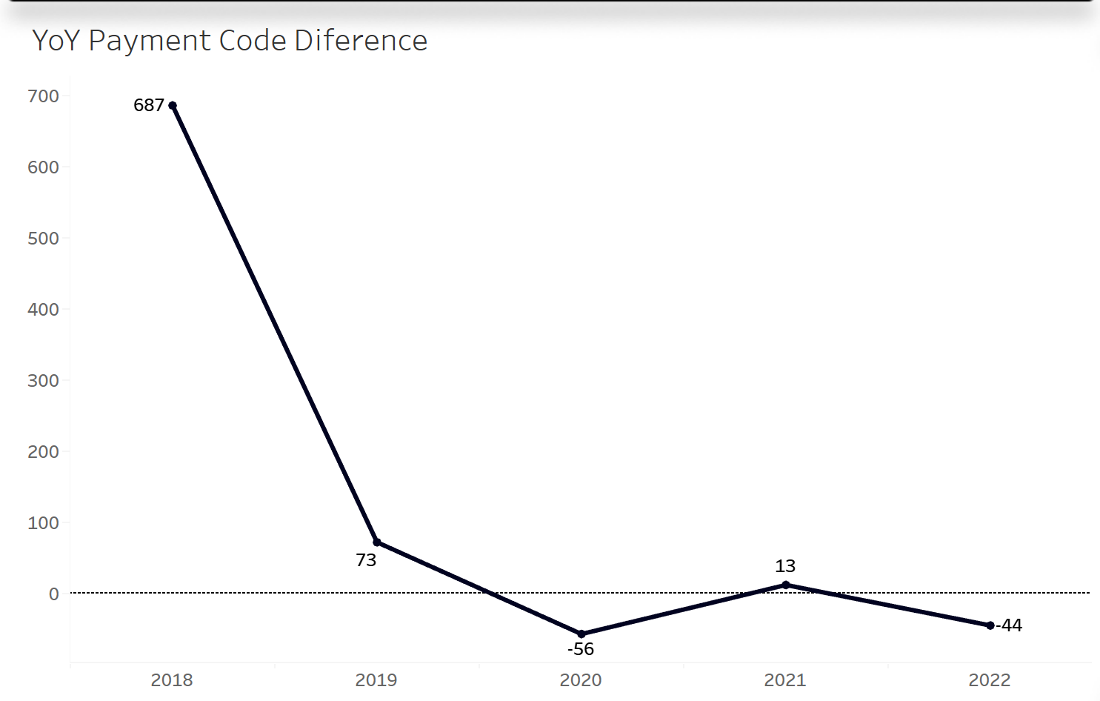

However, the analysis’s most crucial step is to assign points or scores to businesses despite their poor payment habits in order to identify those that are most likely to make payments on time. The points show that “0” predominated the most, which supports the dishonest payment activities.

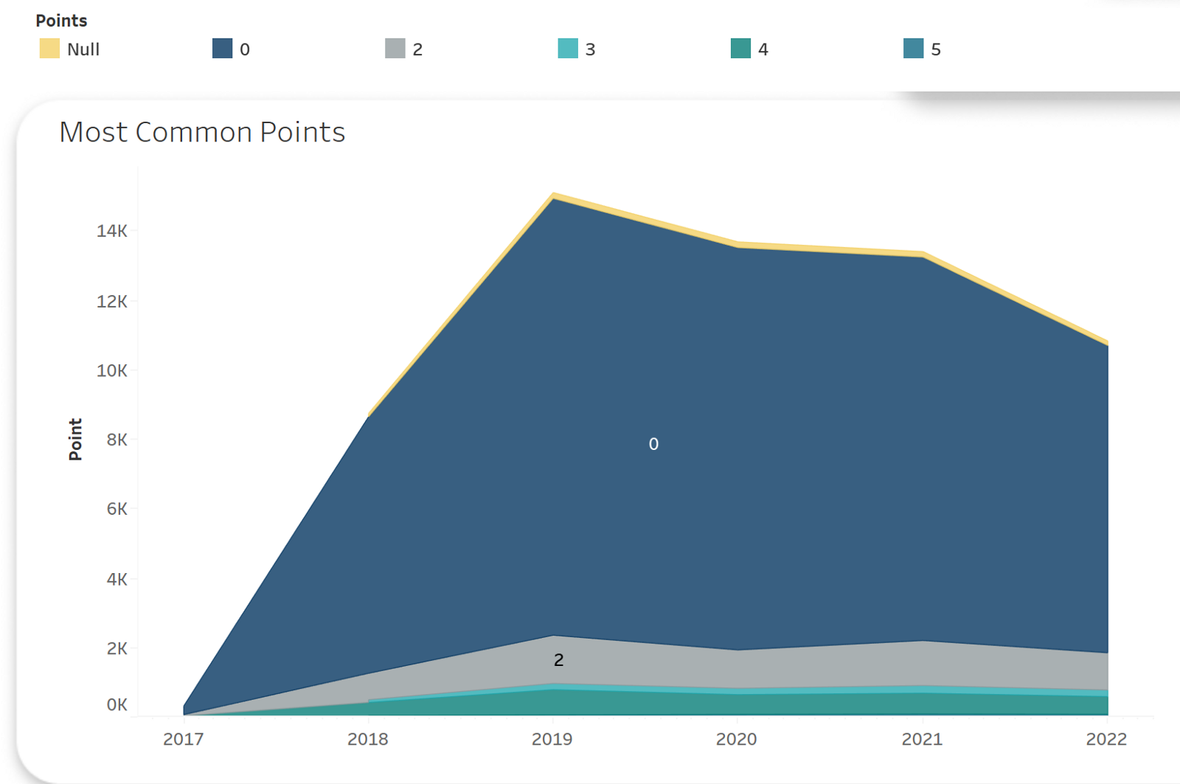

Since I had to take a number of factors into account to determine why a company would merit a low score due to terrible payment methods, this was actually the most difficult portion of the analysis for me. However, as the saying goes, understand your data before you start analyzing, and in this case, I was proven guilty. I eventually discovered a workaround, but after understanding the entire meta-data, which took me days to locate, it seemed incredibly simple.

Simply said, since this is business, and people create deals that are advantageous to them, it is not acceptable to assess a corporation's payment speed by the number of days.

However, it would be nice to have an insight into how often large businesses pay back on average, according to the data.

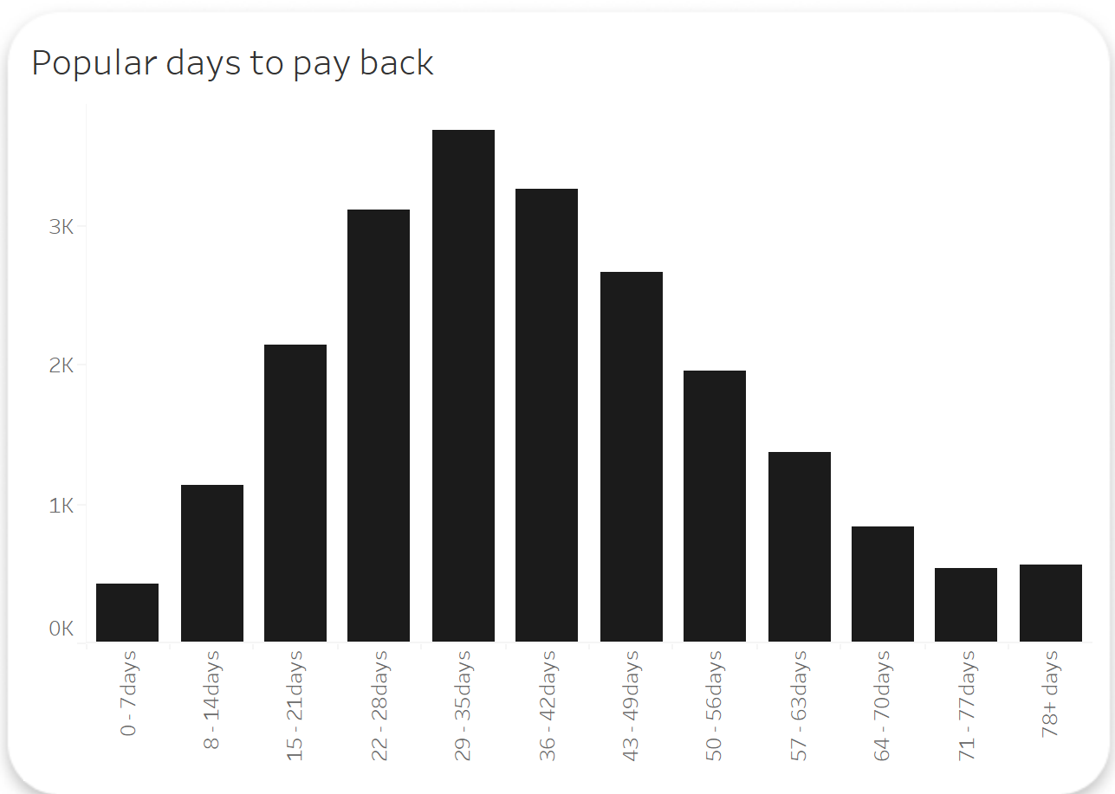

The most popular average days for buyers (businesses) to pay back regardless of their position, either good or bad, stands at between 29 and 35 days**.** But, it is nice to say this alone does not judge a good payment practice.

As a result, I made the decision to rate businesses according to their capacity to pay invoices more quickly within agreed terms and not just the number of days it takes them. Every company or buyer has a standard payment window they agree to work inside, and if they refuse to pay within that window, they submit a report of the invoices they paid outside of that standard agreement. We could therefore conclude that it is good practice to reduce or eliminate payments made outside of the normal payment period.

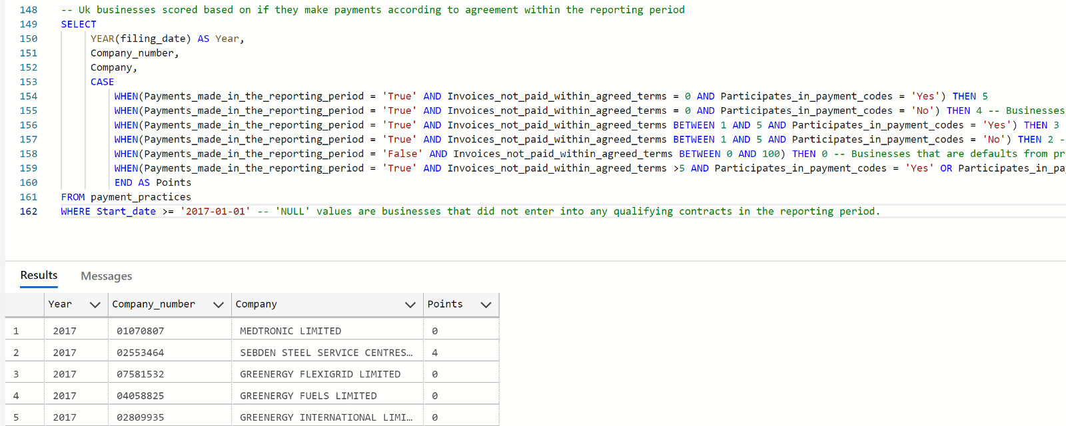

Here’s my break down of the point;

* **Points “5” and “4”** are the **best points** to look out for. It indicates that businesses paid all their invoices in accordance with their standard payment terms.

**Payment Made in Reporting period (True) + 0% default + Participation in Payment Code (True) = 5points**

**Payment Made in Reporting period (True) + 0% default + Participation in Payment Code (False) = 4points**

Payment codes are not mandatory. But, it gives any supplier more confidence in such a business if they have payment codes.

* **Points “3” and “2”** are businesses that paid **95% of invoices** within their standard payment terms and **5%** outside of the agreement.

**Payment Made in Reporting period (True) + 5% default + Participation in Payment Code (True) = 3 points**

**Payment Made in Reporting period (True) + 5% default + Participation in Payment Code (False) = 2points**

* **Point “0”** by the representation is a negative point for businesses that missed their deadlines. They paid anywhere from **6% to 100%** of their invoices outside the terms of the contract. Additionally, also for businesses who were in default from the previous reporting period

**Payment Made in Reporting period (True) + 94% default + Participation in Payment Code (True or False) = 0points**

**Payment Made in Reporting period (False) + 0% - 100% default + Participation in Payment Code (True or False) = 0points**

**NOTE;** Businesses who does not make payment within reporting period but later recorded a % of invoices paid are usually default from the last reporting period.

**“NULL”** values represent companies that did not enter into any qualifying contracts.

### ****How Do I Make A Decision?****

I created it so users or SMEs can just key in the name of any company they want to form a qualifying contract with,

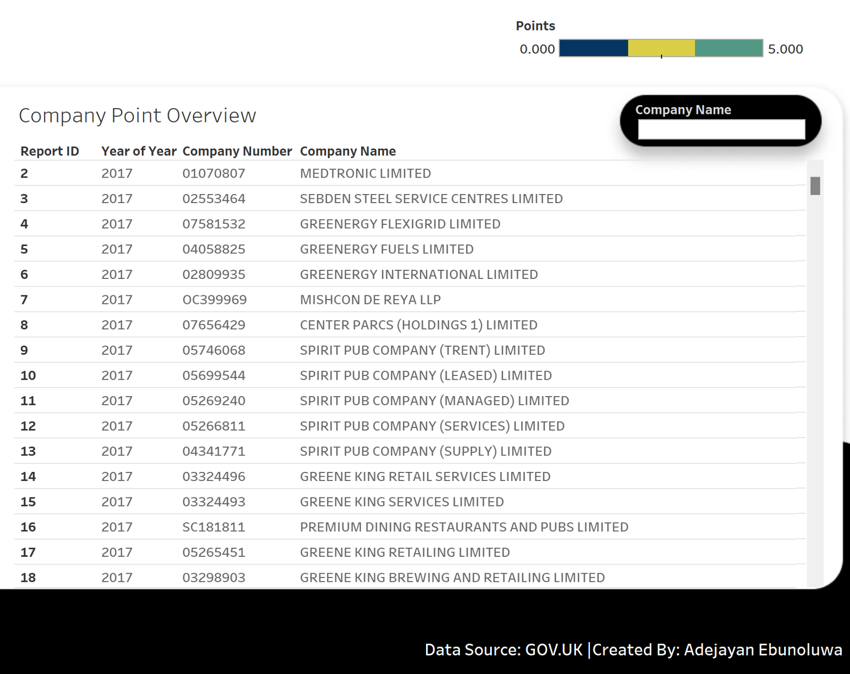

They see their points over time and decide whether or not to do business with them. For instance, KPMG UK is a fantastic option and has a solid track record.

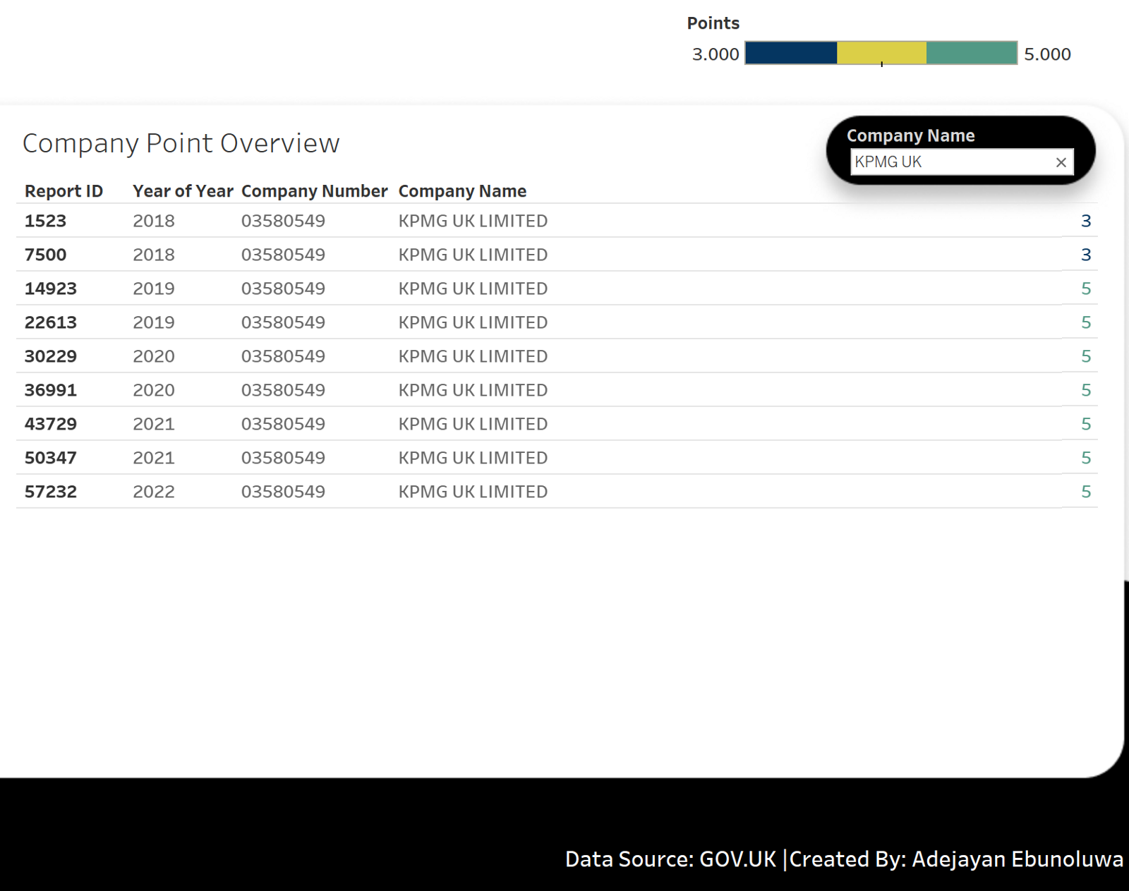

Whereas a business like Greene King Services Limited has a consistency in settling invoices outside of agreed terms. They belong to the category of delaying 94% of invoices outside their standard payment period and terms.

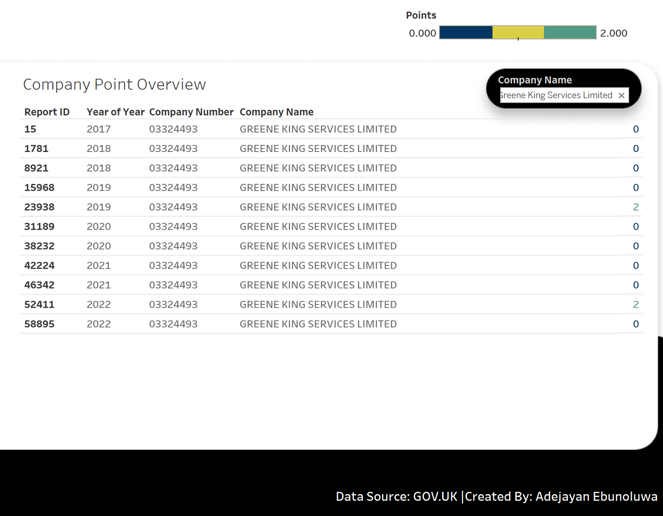

Below is a screenshot of the interactive dashboard. The background was created in Figma, while Tableau handled the rest of the tricks.

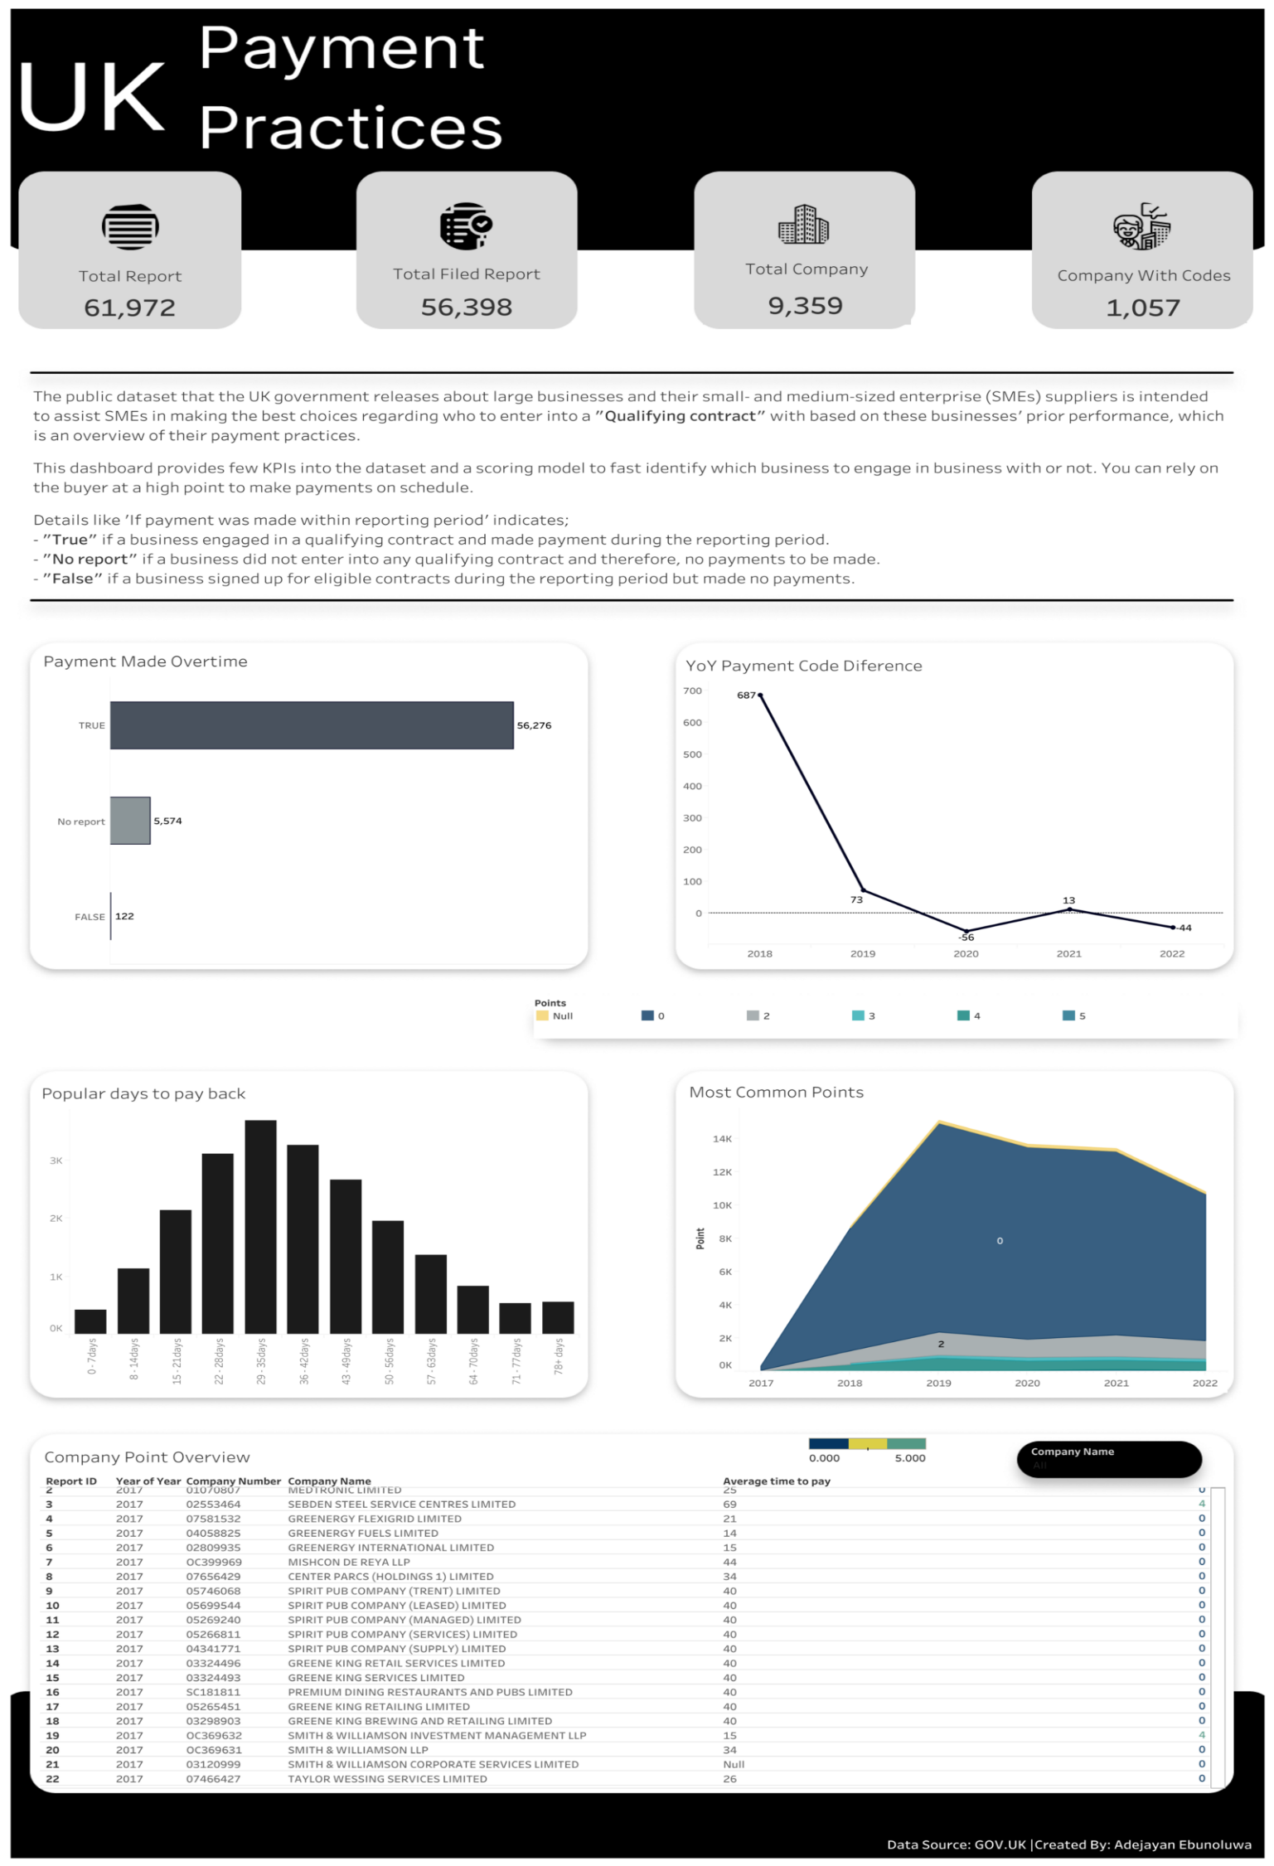

### Relevant Links

* [Tableau Dashboard](https://public.tableau.com/app/profile/ebunoluwa.adejayan/viz/UKPaymentPractices/Dashboard1?publish=yes)
* [GitHub Code](https://github.com/Tsegalion/UK-Payment-Practices-Analysis)
* [LinkedIn Profile](https://www.linkedin.com/in/adejayanebunoluwa/)
* [Data Source](https://lnkd.in/dJzasS8k)